Week-05-Nested Loops - while and for, Jumps in Loops

Week 05-01-practice session coding

Reg no : 241801291

Name : TARRUN.B

Q1)

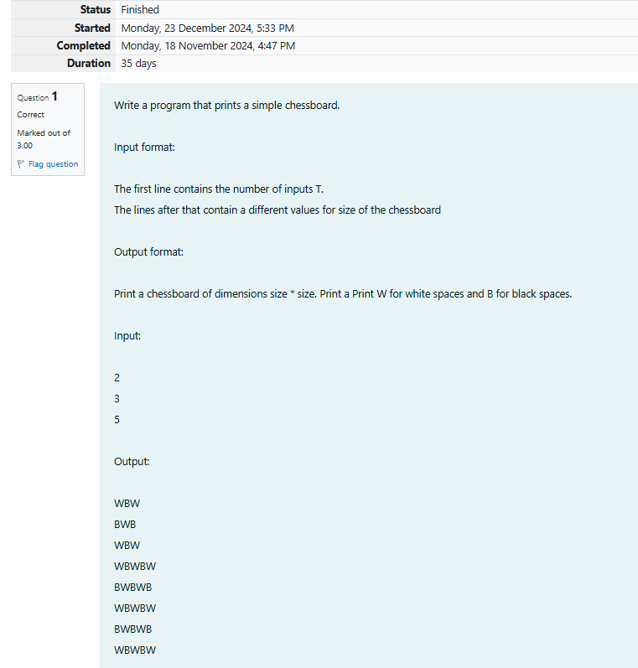

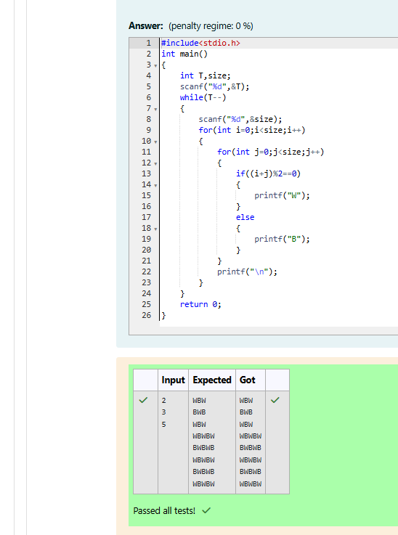

Week 05-01-practice session coding

Reg no : 241801291

Name : TARRUN.B

Q2)

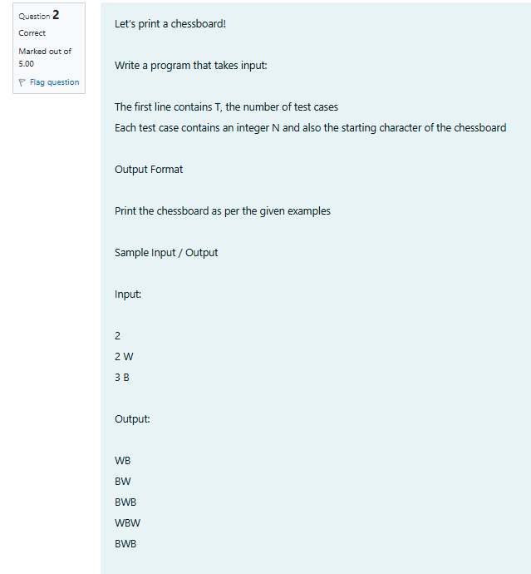

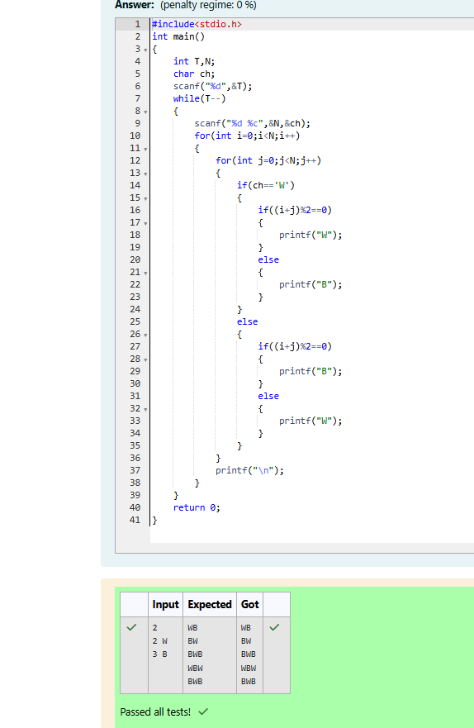

Week 05-01-practice session coding

Reg no : 241801291

Name : TARRUN.B

Q3)

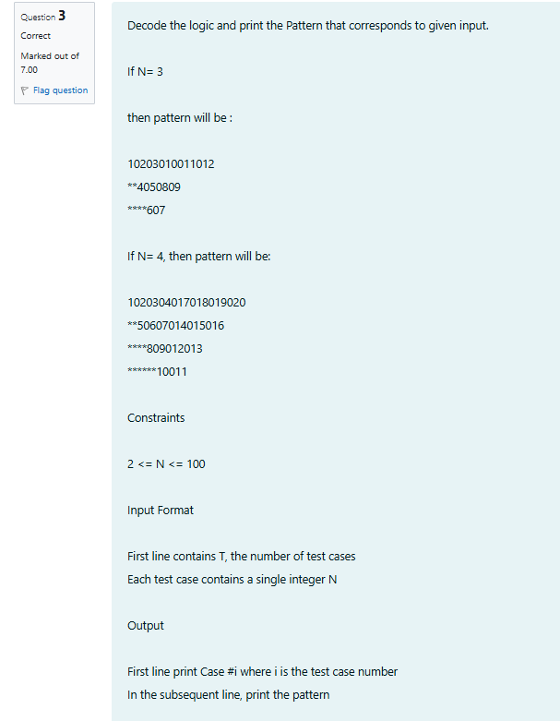

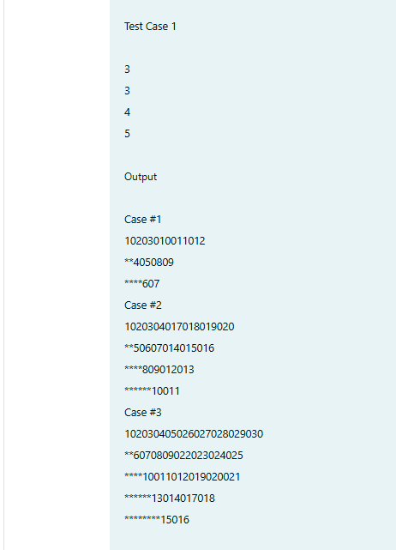

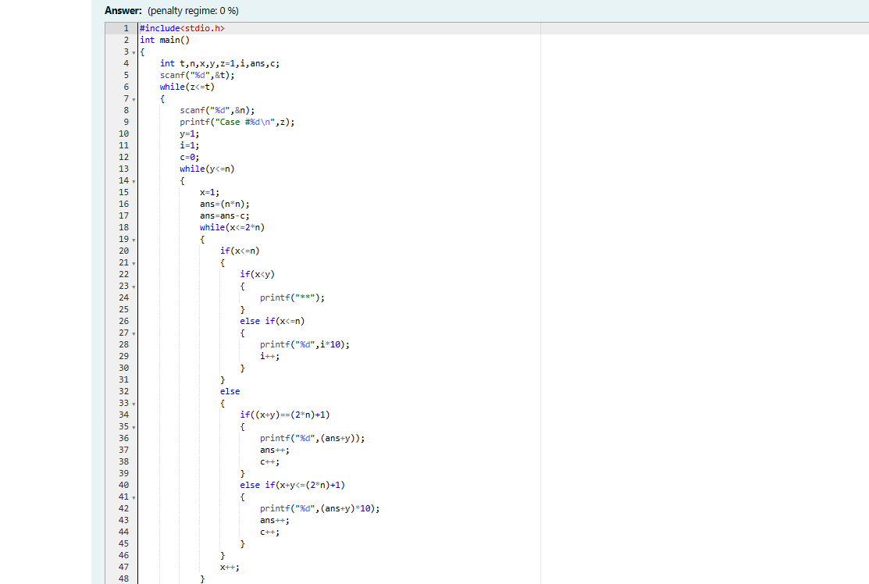

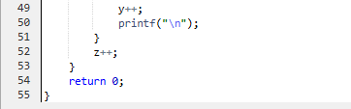

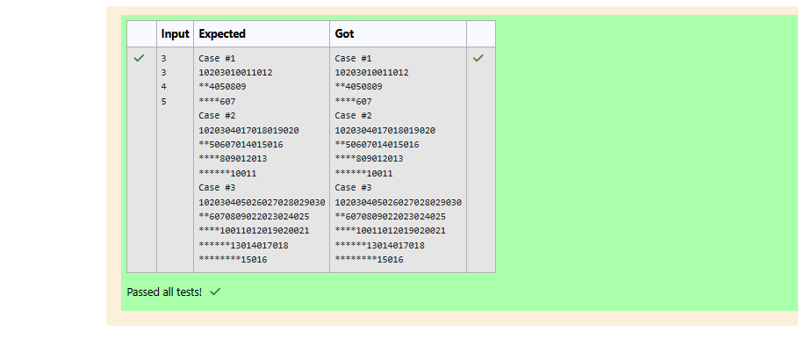

Week 05-02-practice session coding

Reg no : 241801291

Name : TARRUN.B

Q1)

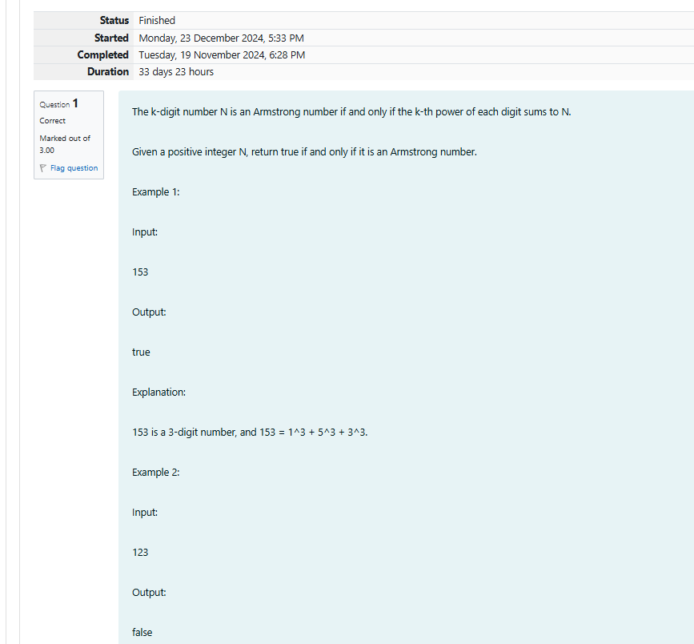

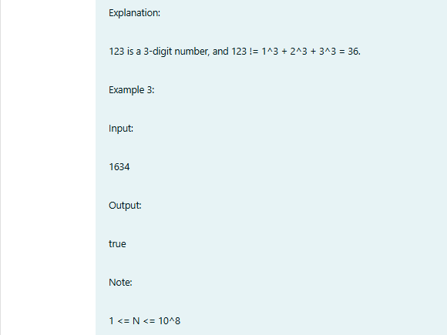

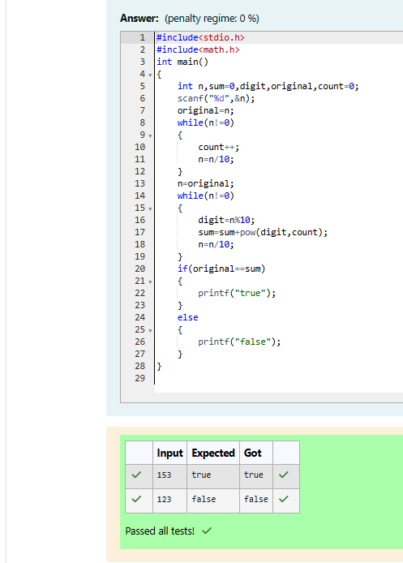

Week 05-02-practice session coding

Reg no : 241801291

Name : TARRUN.B

Q2)



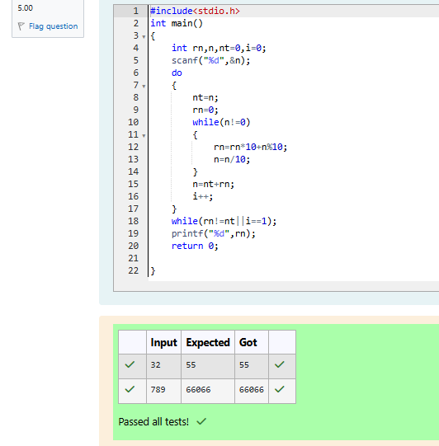

Week 05-02-practice session coding

Reg no : 241801291

Name : TARRUN.B

Q3)

